CAMERA SHOT LIST

Production title Sheet no.

Director Haotian Jiao Date 18/03/2018

Location City Scene With her best friend

Shot # | Shot size / angle | Movement | Notes
22 | Long shot | Take some picture ; talking and laughing; checking the map | High Pavement
23 | Close-up | Walking(Happiness on her face) | Focus on her face
21 | Long shot | Walking on the street and carrying the shopping bag. | Bridlesmith Gate
20 | Close shot | Nice eating and talking. | Need some colorful background.
 |  |  | 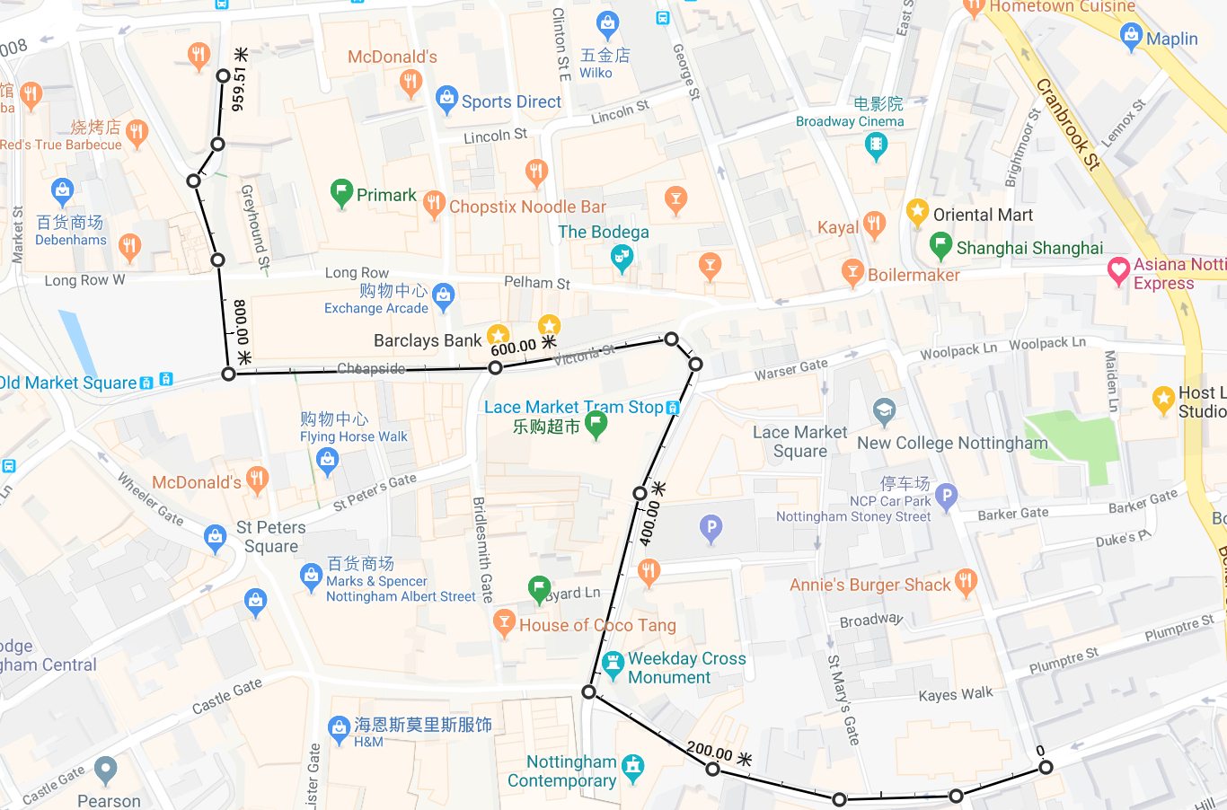

Filmsourcing accepts no legal responsibility for the use of Filmsourcing sample contracts or templates.

